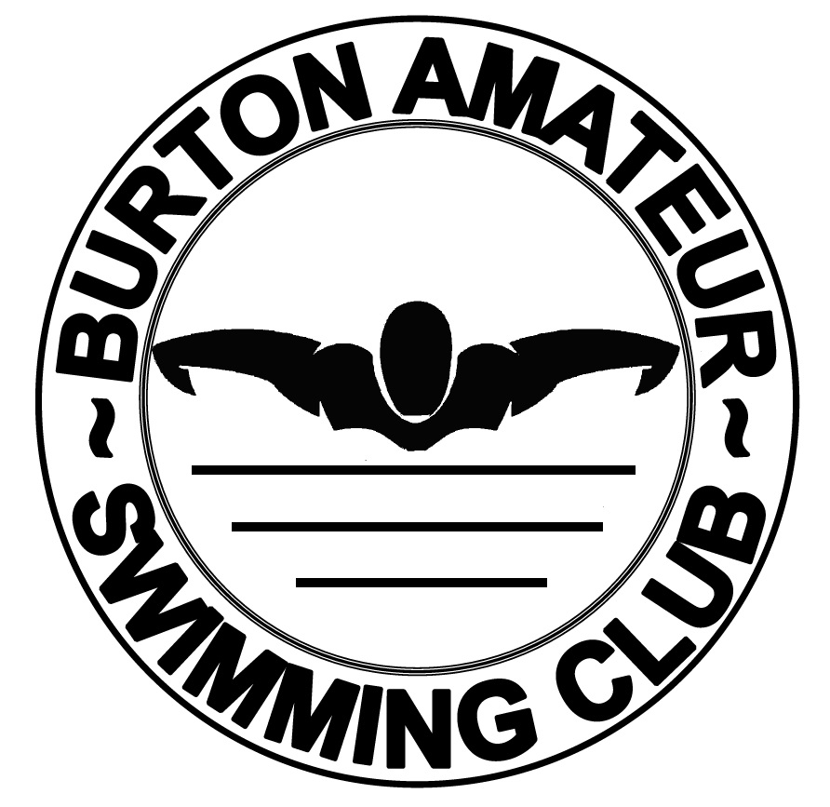
Burton Amateur Swimming Club
Code of Conduct
Members
- It is the responsibility of every member to abide by the Code of Conduct.
- Behaviour and Personal Conduct
- At all times this must be of a high standard and reflect favourably on the sport and the Club. Language in public or relevant group situations must be appropriate and socially acceptable.
- Any other form of behaviour is totally unacceptable
- Will not act in an aggressive manner at any time.
- High levels of respect should be shown at all times to parents, coaches, facilities and staff at venues used by the club.
- Swimmers must not enter the water until instructed by their coach.
- All swimmers are expected to follow instruction and guidance given by coaches, club captains and any club official promptly.
- Abuse, whether physical, verbal or emotional will not be tolerated by the club. This includes abuse via social media. Bullying is totally unacceptable.
- Swimmers should arrive on time for training and galas.
- That is 10 minutes prior to the start of the session for junior swimmers, and 15 minutes prior for senior swimmers, to allow time for stretching and warm up exercises and brief team talk.
- Attend as many sessions as the Coach advises
- Come prepared and ready to train to the best of their abilities, equipped with the relevant pool equipment and a drink.
- Swimmers must inform their individual coach of any injuries or if they feel unwell at the start of each session
- Swimmers shall pay attention to their coaches and follow instruction to the best of their ability
- Swimmers should leave the poolside and change quickly after training and galas. Swimmers should never leave a lone swimmer in the changing room - stay together.
- Swimmers must inform their coach or a committee member if they realise that the person collecting them has not yet arrived. ( Parents of Under 12 must be on site as per Parents Code of Conduct )
- Swimmers should make every effort to represent the club when selected
- If unable to attend, inform the Competition Coach, Club Secretary or Chair as soon as possible, therefore enabling alternative arrangements.
- At Galas each swimmer should arrive at the venue in good time, or give the Gala Manager an estimated time of arrival.
- On arrival swimmers should report to the Coach or Gala Manager.
- Swimmers should wear Club hats and shirts and remain with their team
- Alcohol consumption is totally forbidden under the age of 18. Alcohol should not be consumed prior or during training sessions or a gala.
- The use of drugs or substances other than for medical reasons is strictly forbidden.
- Use of mobile phones on poolside or within the facilities of the changing rooms is strictly forbidden.
- Smoking is prohibited during training sessions and galas.
Parents
- Encourage your child to swim. It should never be a forced participation.
- Ensure your child is on poolside in time for each session.
- Ensure that your child has the correct poolside equipment and drink.
- Parents/Guardians of all children under the age of 12 must stay on the premises at all times during their session time.
- Ensure at least one adults accompanies the swimmer to galas.
- If this is not the swimmer's parent or guardian, ensure that the adult has been given specific responsibilities for that swimmer - e.g. any medical conditions, also that the Coach or Gala Manager is aware of who has responsibility for that swimmer.
- Ensure that the Club has upto date contact details including emergency numbers.
- Arrive in time to collect your swimmer at the end of the training session.
- Do not interrupt the Coach during sessions unless asked to do so or in an emergency.
- If you wish to speak to the Coach about your child, please speak to the Coach at the start of the session to arrange a suitable time, or arrange an appointment through the Club Secretary.
- Parents should only be on poolside if invited.
- Whilst with your child's Coach, fellow swimmers, poolside staff and other parents please treat them with the utmost respect.
- Take an interest in your child's progress by watching training sessions and attending galas whenever possible.
- Focus on your child's efforts rather than the winning or losing.
- Be realistic about your child's ability. Do not push them beyond their capabilities.
- Keep payments to the Club, ASA registration and entry fees up to date.
- Think about becoming involved either as an event organiser, committee member or as an official.
- Show support and be proactive in your child's committee and their efforts to assist all children in the Club.
- Use of mobile phone cameras, or any other form of photography will not be allowed unless by a designated photographer who has completed an entry in the disclosure book.
- Check BASC website, emails, newsletters and notice board for all current information on the club and its activities.
Coaches & Teachers
- Start and finish the session on time.
- Ensure that the correct safety measures are in place.
- Respect the dignity and worth of all members and treat everyone equally.
- Ensuring that at all times they conduct themselves with a high level of personal and professional standards.
- Keep themselves updated with latest techniques and continue to seek to improve their technical and professional skills.
- Coaches must be aware of, and adhere to, the ASA Code of Ethics, and Wave Power, the ASA Child Safeguarding Policy and Procedures.
- Coaches should be approachable to parents/guardians.
- Give feedback to parents/guardians.
- Ensure they establish what is confidential information from the swimmer or parent/guardian before discussion with any third party.
- The Relationship between Coach and Swimmer should remain respectful and based on mutual trust.
- A register of swimmers will be taken at all sessions.
- Coaches should record in the Session Plan all events of bad behaviour during a training session or gala (This should be at the Coaches discretion). Parents should be informed if their child has been entered into the Session Plan.
The Coach has absolute discretion on matters of discipline and swimmers proving to be disruptive maybe asked to leave the pool and remain on poolside until the Coach decides otherwise,

Committee members, officials and volunteers

- At all times, adhere to the ASA Code of Ethics, Rules and Laws

- At all times, adhere to Wavepower.

- At all times, adhere to the ASA Equality and Diversity Policy.

- Adhere fully to the role and job description as outlined by the organisation and never use that role to gain favour for yourself or any individual member.

- Consistently display high standards of behaviour and appearance.

- Treat all members with respect and dignity, value their worth and treat everyone equally, recognising their varying needs and abilities within the context of the sport.

- Encourage and guide members to accept responsibility for their own behaviour and performance.

- Continue to seek and maintain your own development in line with your role and complete a child safeguarding training course, if appropriate to your role.

- Treat all information of a personal nature about individual members as confidential, except in circumstances where to do so would allow the child to be placed at risk of harm or continue to be at risk of harm.

- Encourage all members to obey the spirit of the rules and regulations both in and out of the pool

- Never encourage or condone members, volunteers, officials or parents to violate the rules of the organisation or the sport, and report any violations appropriately.

- Observe the authority and the decision of the officials and only question those decisions in the appropriate manner.

- Treat all competitors and teams of other organisations with respect, whether that is in victory or defeat, and encourage all members to do the same.

- Refer all child safeguarding concerns in accordance with the procedures detailed in Wavepower 2016-19.

The Club
- Will endeavour to treat all children equally and without prejudice regardless of their ability or ethnic/religious background, adhere to the ASA Code of Ethics, and treat all members with respect.
- Make the environment a fun and enjoyable place to be.
- All relevant BASC members are DBS checked.
- Encourage feedback from parents, swimmers and coaches by being positive and proactive at all times.
- Endeavour to inform the relevant parent/guardian at once it their child becomes ill and ensure their wellbeing until the relevant parent/guardian is able to collect him/her.
- Ensure that Wave Power, the ASA Child Protection Policy, and guidance is followed, to keep each child safe and provide a protective culture that puts children's interests first.
- Ensue all activities are properly supervised/taught/coached and consent is obtained for any activity outside of that previously agreed.
- It is expected that all members will adhere to this Code of Conduct, but for breaches of the Code of Conduct the following steps may be taken :
- On the first occasion the lane coach will speak to the swimmer concerned and explain that their conduct is unacceptable and must stop.

- The next occasion will lead to the swimmer being asked to leave the water and sit on the poolside for a given time by that coach.

- A further instance will indicate that the swimmer does not wish to swim on the training session and the swimmer concerned will be asked to leave the pool immediately and get dressed under supervision and then return to the poolside. This will be recorded in the Session Plan as a Verbal Warning. They will then be welcome back at the next training session. Parent/guardians will be informed of the swimmers exclusion from the training session and the reason why.

- Any further repeats of unacceptable behaviour at subsequent training session/galas will result in the swimmer being asked to leave the session. The Chairperson informed and a Written Warning sent to the parent/guardian.

- If swimmers conduct does not improve and further instances are brought to the Chair person’s attention, the swimmer will be issued with a fixed term suspension and a Final Written Warning. This will mean that the swimmer will be unable to take part in any activity (training session/gala). Fees for this period will still be payable and no rebate will be given.

- Finally, after the suspension period and on return to normal training sessions if the swimmer behaviour continues to be unacceptable, the issue will be taken to the next committee meeting with a request that the swimmer will be permanently excluded from the Club.

- Serious breaches of reasonable behaviour may, at the discretion of the Committee lead to instant suspension of the swimmer, e.g. fighting, bullying, damage to facilities or excessive bad behaviour during either a training session, gala or Club event. This suspension will remain until disciplinary committee hearing has been held, and a decision made on the individual's behaviour and the relevant actions required.

- Each swimmer has the right to appeal against any decision made under this Code of Conduct and can do so by submitting it in writing to the Club's secretary within 14 days. This will then be discussed at the next management committee meeting and the individual will be informed of the decision made.

It is every member's responsibility including Coaches and the Club to uphold the Code of Conduct, challenge any behaviour that is inappropriate and inform an official of any breach of the Club's Code of Conduct.
Please note that depending upon the severity of the behaviour, BASC may bypass or invoke the above procedure at any stage.
Such action may be overridden by the ASA complaints procedure.

